**Horse - Wooden Animal Wall Mount**

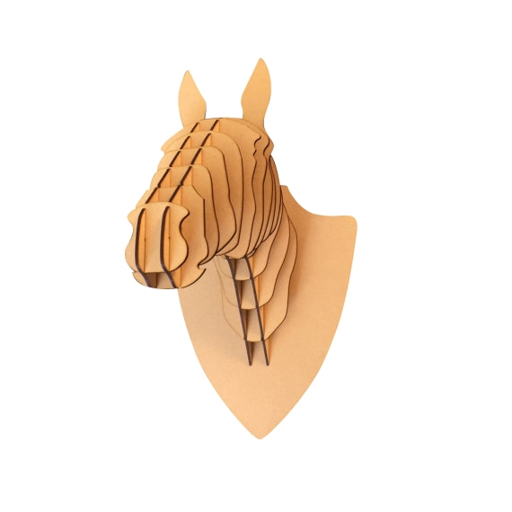The Horse Wooden Animal Wall Mount is an elegant and timeless decor piece that brings the grace and strength of a horse into your home. Crafted from high-quality wood, this mount showcases the finely detailed features of the horse’s head, with careful attention to the mane, facial expressions, and overall silhouette. The natural wood finish adds a warm, rustic touch, while maintaining a sophisticated and minimalist design. Perfect for equestrian enthusiasts or those seeking a classic, nature-inspired element, the Horse Wooden Wall Mount serves as a stunning focal point that evokes both beauty and power in any room.